ABSTRACT

This project is aimed at developing of Web based and central recruitment process system for the HR Group for a company. Some features of this system will be creating vacancies, storing Applicants data, Interview process initiation, Scheduling Interviews, Storing Interview result for the applicants and finally hiring of the applicants. Reports may be required to be generated for the use of HR group.

This project is an online portal which is useful for job seekers to find suitable jobs online. The objective behind this is to build a website where the jobseekers can register themselves to apply for job and organizations registers themselves to post job vacancies..

This project is aimed at developing an online search Portal for the Placement Details for job seekers. The system is an online application that can be accessed throughout the organization and outside as well with proper login provided. This system can be used as an Online Job Portal for job seekers. Job Seekers logging should be able to upload their information in the form of a CV. Visitors/Company representatives logging in may also access/search any information put up by Job aspirants.

**Chapter 1**

**INTRODUCTION**

This project is aimed at developing an online search Portal for the Placement Details for job seekers. The system is an online application that can be accessed throughout the organization and outside as well with proper login provided. This system can be used as an Online Job Portal for job seekers. Job Seekers logging should be able to upload their information in the form of a CV. Visitors/Company representatives logging in may also access/search any information put up by Job aspirants. The purposed project “Job portal” tends to find the best of person searching for a well matched job. Finding a perfect match is difficult in life and especially in case of job. The person searching for job requires a solution that should be feasible. As it is not possible for a person to be able to go and visit each and every company for a vacant seat.Morever it is not possible for every company to monitor every candidate in search of a job and contact them.

Thus, proposed system tends to find solutions to particular problem. The persons in search of job may login the website. Moreover the companies may also register for entry of a vacant job.

The proposed system helps in bridging this gap. After login in the candidate may create a profile. This profile would include every detail of candidate as personnel information as well as the job characteristics and description of type of job required. The user can enter the data he/she may like to add in his/her profile based on his/her choice. The candidate may also update his/her profile whenever required.

**1.1 PURPOSE**

This system can be used as an Online Job Portal for the Placements providing to the undergraduates and employees who are seeking for a job placement. Job Seeker logging into the system and he can should be able to upload their information in the form of a CV. Visitors/Company representatives logging in may also access/search any information put up by Job Seeker. The companies may also enter the profile of the job vacancy and the other details. The details of company may be fully entered and be updated time to time so that the candidate gets the best of information he/she wants. The company may also update their entries as per their needs.

The system tends to match the candidates profile with the companies profile and inform the candidates whose profile matches. Thus the system tends to provide the candidates with list of companies matching their profiles. Thus after obtaining a list of companies matching his/her profile a candidate may show their interest on the particular company they want to try for based on the choice of job profile .Thus obtaining the choice of job profile they are most interested for. Moreover the companies also get the list of interested candidate with the profile they needed. Thus reducing the complex task of companies .now from the obtained list the company can choose the candidate by any set of task.

**1.2SCOPE**

Scope of this document is –

1. This document describes about the various phases of the project.
2. This document also contains the screenshots of various parts of the project such as its front end, database and support.

It also gives a brief description about the various tools and technologies used in the completion of the project.

**1.3DEFINITIONS, ACRONYMS AND ABBREVIATIONS**

Various technical terms is used in this document often. Their descriptions are as follows:-

* Admin: - It is administrator of system. It has all rights of system.
* MySQL: - A database management system that provides a flexible and efficient database platform to maintain records of the system.
* JSP: - It is Java Server Pages. It is used to create dynamic web content.
* UML: - It is Unified Modeling Languages a standard language for writing software blueprints. The UML may be used to visualize, specify, construct and document.
* XML: - It is Extensible Markup Languages, a text based format that let developers describe, deliver and exchange structured data between a range of applications to client for display and manipulation.

**1.4 PROBLEM IN EXISTING SYSTEM**

* Cannot Upload and Download the latest updates.
* No use of Web Services and Remote Accessing.
* Risk of mismanagement and of data when the project is under development.
* Less Security.
* No proper coordination between different Applications and Users.

**1.5 SOLUTION OF THE PROBLEMS**

The development of the new system contains the following activities, which try to automate the entire process keeping in view of the database integration approach.

1. User friendliness is provided in the application with various controls.
2. The system makes the overall project management much easier and flexible.
3. Readily upload the latest updates, allows user to download the alerts by clicking the URL.

**1.6 OVERVIEW**

* The system tends to find jobs appropriate to candidates.
* Companies could get a chance to choose best among candidates.

**Chapter 2**

**SYSTEM ANALYSIS**

After analyzing the requirements of the task to be performed, the next step is to analyze the problem and understand its context. The first activity in the phase is studying the existing system and other is to understand the requirements and domain of the new system. Both the activities are equally important, but the first activity serves as a basis of giving the functional specifications and then successful design of the proposed system. Understanding the properties and requirements of a new system is more difficult and requires creative thinking and understanding of existing running system is also difficult, improper understanding of present system can lead diversion from solution.

The system tends to match the candidates profile with the companies profile and inform the candidates whose profile matches. Thus the system tends to provide the candidates with list of companies matching their profiles. Thus after obtaining a list of companies matching his/her profile a candidate may show their interest on the particular company they want to try for based on the choice of job profile .Thus obtaining the choice of job profile they are most interested for. Moreover the companies also get the list of interested candidate with the profile they needed. Thus reducing the complex task of companies .now from the obtained list the company can choose the candidate by any set of task.

Every company has different way to choose from list of given candidates. Some prefer to take test and those who pass test are taken to interview round others take direct call for interview. The based on the task they carry these choose the desired candidate.

However, the system reduces their task of obtaining the best of candidates to much less level. The system does this by providing a precise list of only the matching candidates profile .thus saving both time and money of companies. Companies of different level may add their profiles in proposed system thus reduce their task. The proposed system has derived inspirations from the current popular systems as naukri.com, jobs.com etc.

**2.2. ANALYSIS MODEL**

The model that is basically being followed is the WATER FALL MODEL, which states that the phases are organized in a linear order. First of all the feasibility study is done. Once that part is over the requirement analysis and project planning begins. If system exists one and modification and addition of new module is needed, analysis of present system can be used as basic model.

The design starts after the requirement analysis is complete and the coding begins after the design is complete. Once the programming is completed, the testing is done. In this model the sequence of activities performed in a software development project are: -

* Requirement Analysis
* Project Planning
* System design
* Detail design
* Coding
* Unit testing
* System integration & testing

Here the linear ordering of these activities is critical. End of the phase and the output of one phase is the input of other phase. The output of each phase is to be consistent with the overall requirement of the system. Some of the qualities of spiral model are also incorporated like after the people concerned with the project review completion of each of the phase the work done.

**WATER FALL MODEL** was being chosen because all requirements were known beforehand and the objective of our software development is the computerization/automation of an already existing manual working system.

**Product**

**Product**

**Input**

**Output**

**Process**

**GUI’S**

In the flexibility of the uses the interface has been developed a graphics concept in mind, associated through a browser interface. The GUI’S at the top level have been categorized as

* Administrative user interface
* The operational or generic user interface

The administrative user interface concentrates on the consistent information that is practically, part of the organizational activities and which needs proper authentication for the data collection. The interfaces help the administrations with all the transactional states like Data insertion, Data deletion and Date updating along with the extensive data search capabilities.

The operational or generic user interface helps the users upon the system in transactions through the existing data and required services. The operational user interface also helps the ordinary users in managing their own information helps the ordinary users in managing their own information in a customized manner as per the assisted flexibilities

# NUMBER OF MODULES

The system after careful analysis has been identified to be presented with the following modules:

**THE MODULES INVOLVED ARE:**

* Admin
* Job Seeker
* Job Provider
* Notification
* Search
* Report
* Authentication

**ADMIN**

In this module Admin will add all the qualifications, skill, experience, city, state, country and update and delete information about the job provider or job seeker he can also search for the job seeker and he can send mail to offer the job to job seeker and he can also see the jobs add by the job provider.

**JOB SEEKER**

In this module Job Seeker register himself and upload his resume and fill the profile give by admin and after login he will search for the job on various conditions and he can change his profiles and resume and he can apply for the jobs based on various conditions. He can see the response of the company and he can call the company person for the interview.

**JOB PROVIDER**

In this module Job Provider register himself and his company and after login he will add new job and he can search for the job seekers on various conditions and he can offer the job to job seeker According to the job profile and he can also see the response from the job seekers and send the mail.

**NOTIFICATION**

In this module admin and job provider send the notification to the job seeker in the form of email.

**REPORTS**

This module contains all the information about the reports generated by the admin based on the particular job seeker, particular job provider, all job seeker and job provider, all jobs generated by the job providers.

**AUTHENTICATION**

This module contains all the information about the authenticated user. User without his username and password can’t enter into the login if he is only the authenticated user then he can enter to his login.

**PROJECT INSTRUCTIONS:**

* Based on the given requirements, conceptualize the Solution Architecture. Choose the domain of your interest otherwise develop the application for ultimatedotnet.com. Depict the various architectural components, show interactions and connectedness and show internal and external elements. Design the web services, web methods and database infrastructure needed both and client and server.
* Provide an environment for up gradation of application for newer versions that are available in the same domain as web service target.

**PROPOSED SYSTEM**

To debug the existing system, remove procedures those cause data redundancy, make navigational sequence proper. To provide information about audits on different level and also to reflect the current work status depending on organization/auditor or date. To build strong password mechanism.

**NEED FOR COMPUTERIZATION**

We all know the importance of computerization. The world is moving ahead at lightening speed and everyone is running short of time. One always wants to get the information and perform a task he/she/they desire(s) within a short period of time and too with amount of efficiency and accuracy. The application areas for the computerization have been selected on the basis of following factors:

Minimizing the manual records kept at different locations.

* There will be more data integrity.
* Facilitating desired information display, very quickly, by retrieving information from users.
* Facilitating various statistical information which helps in decision-making?
* To reduce manual efforts in activities that involved repetitive work.
* Updating and deletion of such a huge amount of data will become easier.

**2.6 INPUT AND OUTPUT**

The main inputs, outputs and major functions of the system are as follows

**INPUTS:**

* + Head operator enters his or her user id and password.
  + User requests the reports.
  + User requests the search.
  + Head operator can edits the personal details and so on.

**OUTPUTS:**

* Head operator receives personal details.
* Operator receives the personal details.
* Technicians receive personal and technical details.
* Users receive requested reports.
* Displays search result.

**Chapter-3**

## FUNCTIONAL REQUIREMENTS

**Output Design**

Outputs from computer systems are required primarily to communicate the results of processing to users. They are also used to provides a permanent copy of the results for later consultation. The various types of outputs in general are:

* External Outputs, whose destination is outside the organization,
* Internal Outputs whose destination is within organization and they are the
* User’s main interface with the computer.
* Operational outputs whose use is purely within the computer department.
* Interface outputs, which involve the user in communicating directly with

**Output Definition**

The outputs should be defined in terms of the following points:

Type of the output

* + - Content of the output
    - Format of the output
    - Location of the output
    - Frequency of the output
    - Volume of the output
    - Sequence of the output

It is not always desirable to print or display data as it is held on a computer. It should be decided as which form of the output is the most suitable.

For Example

* + - Will decimal points need to be inserted
    - Should leading zeros be suppressed.

**Input Design**

* Input design is a part of overall system design. The main objective during the input design is as given below: To produce a cost-effective method of input.
* To achieve the highest possible level of accuracy..
* To ensure that the input is acceptable and understood by the user.

**Input Types:**

It is necessary to determine the various types of inputs. Inputs can be categorized as follows:

* External inputs, which are prime inputs for the system.
* Internal inputs, which are user communications with the system.
* Operational, which are computer department’s communications to the system?
* Interactive, which are inputs entered during a dialogue.

**Error Avoidance**

At this stage care is to be taken to ensure that input data remains accurate form the stage at which it is recorded up to the stage in which the data is accepted by the system. This can be achieved only by means of careful control each time the data is handled.

**Chapter-4**

**EXTERNAL REQUIREMENTS**

**4.1HARDWARE REQUIREMENTS:**

* PIV 2.8 GHz Processor and Above
* RAM 512MB and Above
* HDD 20 GB Hard Disk Space and Above

**4.2SOFTWARE REQUIREMENTS:**

WINDOWS OS (XP / 2000 / 200 Server / 2003 Server)

* Visual Studio .Net 2005 Enterprise Edition
* Internet Information Server 5.0 (IIS)
* Visual Studio .Net Framework (Minimal for Deployment)
* SQL Server 2000 Enterprise Edition

**Chapter 5**

**TOOLS AND TECHNOLOGY USED**

**5.1 INTRODUCTION TO JAVA**

Java is a programming language evolved from a language named Oak. Oak was developed in the early nineties at Sun Microsystems as a platform-independent language aimed at allowing entertainment appliances such as video game consoles and VCRs to communicate. Oak was first stated to appear in television set-top boxes designed to provide video-on-demand services. Just as the deals with the set-top box manufacturers were falling through, the World Wide Web was coming to life. As Oak’s developers began to recognize this trend, their focus shifted to the Internet and Web Runner, an Oak-enabled browser, was born. Oak’s name was changed to Java and Web Runner became the Hot Java web browser. The excitement of the Internet attracted software vendors such that Java development tools from many vendors quickly became available.

**5.1.1 Significant Language Features**

* **Platform Independence -** Java compilers do not produce native object code for a particular platform but rather ‘byte code’ instructions for the Java Virtual Machine (JVM). Making Java code work on a particular platform is then simply a matter of writing a byte code interpreter to simulate a JVM. What this all means is that the same compiled byte code will run unmodified on any platform that supports Java.
* **Object Orientated –** Java is an object oriented language. It follows basic OOPs concepts like encapsulation, abstraction, inheritance and polymorphism.
* **Rich Standard Library –** One of Java’s most attractive features is its standard library. The Java environment includes hundreds of classes and methods in six major functional areas.
* Language Support classes for advanced language features such as strings, arrays, threads and exception handling.
* Utility classes like a random number generator, date and time functions, and container classes.
* Input/output classes to read and write data of many types to and from a variety of sources.
* Networking classes to allow inter-computer communications over a local network or the Internet.
* **Garbage Collection –** Java does not require programmers to explicitly free dynamically allocated memory. This makes Java programs less prone to memory errors.

**5.1.2 Areas of Application**

* **Android Apps**: - Android apps are actually written in Java programming language, with Google’s Android API, which is similar to JDK. However, android uses different JVM and different packaging.
* **Web Applications**: - Java is used for E commerce and web applications. Even simple Servlet, JSP and Struts based web applications are quite popular on various government projects.
* **Trading Applications**: - Third party trading application, which is also part of bigger financial services industry, also uses Java. Popular trading application like Murex, which is also in many banks, is also written in Java.

**5.2 INTRODUCTION TO HTML**

**HTML** or **Hyper Text Markup Language** is the standard markup language used to create web pages. HTML is written in the form of HTML elements consisting of tags enclosed in angle brackets.HTML tags most commonly come in pairs like <h1> and </h1>, although some tags represent empty elements and so are unpaired. The first tag in a pair is the start tag, and the second tag is the end tag. The simplest tag is nothing more than a name appropriately enclosed in brackets. More complicated tags contain one or more attributes, which specify behaviour of the tag.

**Basic Tags in HTML**

* **<head></head>**– this tag contains information about the document such as title of the document, author of the document etc. Information inside this tag does not display outside.
* **<body></body>** – this tag contains real content of the document that you see on your screen.
* **<header>, <footer>** – you won’t need to manually name IDs for headers and footers, as now you have a pre-defined tag for them
* **<p></p>**– it is used to create paragraph.
* **<div></div>** – allows creation of several sections or subsections of a page.
* **<table></table>** – the table tag is a container for every other tag used to create a table in HTML.
* **<title>** – the title of the page.

**5.3 INTRODUCTION TO CSS 3**

CSS is a style sheet language, and is an acronym that stands for, "Cascading Style Sheets". CSS is used to control the presentation and appearance of web pages.  The way we do this is by creating Style Rules and applying these Style Rules to the HTML page elements.  Fortunately, Expression Web simplifies this process and makes the creation of CSS styles a little easier.HTML and CSS are used together to Design Web Pages. HTML is used to create the Structure of a web page, while CSS Styles the Structure. Without CSS, our Web Pages would look dull and lifeless. The 3 Types of CSS Style Declarations are as follows: -

* **Internal (Embedded) Styles** are defined in the <head> section of the "current" web page. These Styles can be used only for the web page in which they are embedded. Therefore, you would need to create these styles over and over again for each web page you wish to style.  When using the style builder in Expression Web, Define the style in the Current Page. This will create an Internal Style.

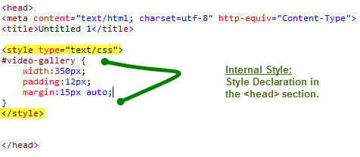

* **Inline Styles** are defined within the HTML markup of a particular page element. Inline Styles cannot be reused at all, period.  Inline styles are placed directly inside an HTML element in the code.  We cannot use the Style Builder to make an Inline Style. Instead, to purposely create an inline style requires you to go into the HTML code and type the style yourself. Inline styles defeat the purpose of using CSS and negate most, if not all of CSS's advantages, like the separation of content from presentation. Therefore, the use of Inline Styles should be kept to an absolute minimum.  Use Inline Styles only as a last resort.

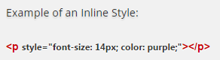

* **External Styles** are defined on the External Style Sheet, which is linked to the web page(s). An External Style Sheet is a separate page (file) which is then linked to the web page.  Therefore, the styles are External to, or outside of, the Web Page. The External Style Sheet is basically a Text File that is Saved As a .css file. We must Link the External Style Sheet to the Web Page(s) in order for the External Styles to be applied as specified.

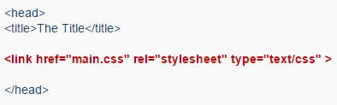

**5.4 INTRODUCTION TO JAVASCRIPT**

**JavaScript** is a [high level](https://en.wikipedia.org/wiki/High-level_programming_language), [dynamic](https://en.wikipedia.org/wiki/Dynamic_programming_language), [typed](https://en.wikipedia.org/wiki/Programming_language#Type_system), and [interpreted](https://en.wikipedia.org/wiki/Interpreted_language) programming language. It has been standardized in the [ECMA Script](https://en.wikipedia.org/wiki/ECMAScript) language specification. Alongside [HTML](https://en.wikipedia.org/wiki/HTML) and [CSS](https://en.wikipedia.org/wiki/CSS), it is one of the three essential technologies of [World Wide Web](https://en.wikipedia.org/wiki/World_Wide_Web) content production; the majority of [websites](https://en.wikipedia.org/wiki/Website) employ it and it is supported by all modern [web browsers](https://en.wikipedia.org/wiki/Web_browser) without [plug-ins](https://en.wikipedia.org/wiki/Browser_extension). JavaScript is [prototype-based](https://en.wikipedia.org/wiki/Prototype-based_programming) with first class functions, making it a [multi-paradigm](https://en.wikipedia.org/wiki/Multi-paradigm) language, supporting [object-oriented](https://en.wikipedia.org/wiki/Object-oriented_programming), [imperative](https://en.wikipedia.org/wiki/Imperative_programming), and [functional](https://en.wikipedia.org/wiki/Functional_programming) programming styles. It has an [API](https://en.wikipedia.org/wiki/Application_programming_interface) for working with text, [arrays](https://en.wikipedia.org/wiki/Array_data_type), dates and [regular expressions](https://en.wikipedia.org/wiki/Regular_expression), but does not include any [I/O](https://en.wikipedia.org/wiki/Input/output), such as networking, storage or graphics facilities, relying for these upon the host environment in which it is embedded.

The most common use of JavaScript is to add client-side behaviour to [HTML](https://en.wikipedia.org/wiki/HTML) pages, a.k.a. [Dynamic HTML](https://en.wikipedia.org/wiki/Dynamic_HTML) (DHTML). Scripts are embedded in or included from [HTML](https://en.wikipedia.org/wiki/HTML) pages and interact with the [Document Object Model](https://en.wikipedia.org/wiki/Document_Object_Model) (DOM) of the page. Some simple examples of this usage are:

Loading new page content or submitting data to the server via [AJAX](https://en.wikipedia.org/wiki/AJAX) without reloading the page (for example, a social network might allow the user to post status updates without leaving the page)

* Animation of page elements, fading them in and out, resizing them, moving them, etc.
* Interactive content, for example games, and playing audio and video
* [Validating](https://en.wikipedia.org/wiki/Data_validation) input values of a [Web form](https://en.wikipedia.org/wiki/Form_(HTML)) to make sure that they are acceptable before being submitted to the server.
* Transmitting information about the user's reading habits and browsing activities to various websites. Web pages frequently do this for [web analytics](https://en.wikipedia.org/wiki/Web_analytics), [ad tracking](https://en.wikipedia.org/wiki/Ad_tracking),[personalization](https://en.wikipedia.org/wiki/Personalization) or other purposes.

**Var** v;

v=1;

**var**get Value=(**function**(v){

**return function**(){**return**v;};

})(v);

v=2;

getValue();*// 1*

**5.5 INTRODUCTION TO DATABASE**

A database is an organized collection of data. The data are typically organized to model relevant aspects of reality in a way that supports processes requiring this information.

A **database management system** or **DBMS** is software designed to assist in maintaining and utilizing large collections of data, and the need for such systems, as well as their use, is growing rapidly. The alternative to using a DBMS is to useadhoc approaches that do not carry over from one application to another. The area of database management systems is a microcosm of computer science in general. The issues addressed and the techniques used span a wide spectrum, including languages, object-orientation and other programming paradigms, compilation, operating systems, concurrent programming, data structures, algorithms, parallel and distributed systems, user interfaces, expert systems and artificial intelligence, statistical techniques, and dynamic programming.

Well known DBMSs include MySQL, Maria DB, PostgreSQL, SQLite, Microsoft SQL Server, Microsoft Access, Oracle, SAP HANA,dBASE, FoxPro, IBM DB2, Libre Office Base, FileMaker Pro and Intersystem Cache. A database is not generally portable across different DBMSs, but different DBMSs can interoperate by using standards such as SQL and ODBC or JDBC to allow a single application to work with more than one database.

**Advantages of a DBMS :**

* **Data Independence:** Application programs should be independent as possible from details of data representation and storage. The DBMS can provide an abstract view of the data to insulate application code from such details.
* **Efficient data access:** A DBMS utilizes a variety of sophisticated techniques to store and retrieve data efficiently. This feature is especially important if the data is stored on external storage devices.
* **Data integrity and security:** If data is always accessed through the DBMS, the DBMS can enforce integrity constraints on the data. For example, before inserting salary information for an employee, the DBMS can check that the department budget is not exceeded. Also, the DBMS can enforce access controls that govern what data is visible to different classes of users.
* **Concurrent access and crash recovery:** A DBMS schedules concurrent accesses to the data in such a manner that users can think of that data as being accessed by only one user at a time. Further, the DBMS protects users from the effects of system failure.
  1. **INTRODUCTION TO MYSQL**

MySQL is a popular choice of database for use in web applications, and is a central component of the widely used [LAMP](https://en.wikipedia.org/wiki/LAMP_(software_bundle)) open source web application software stack (and other "[AMP](https://en.wikipedia.org/wiki/List_of_AMP_packages)" stacks). LAMP is an acronym for "[Linux](https://en.wikipedia.org/wiki/Linux), [Apache](https://en.wikipedia.org/wiki/Apache_HTTP_Server), MySQL, [Perl](https://en.wikipedia.org/wiki/Perl)/[PHP](https://en.wikipedia.org/wiki/PHP)/[Python](https://en.wikipedia.org/wiki/Python_(programming_language))." [Free-software](https://en.wikipedia.org/wiki/Free_software)-open source projects that require a full-featured database management system often use MySQL. Applications MySQL is offered under two different editions: the open source MySQL Community Server and the proprietary [Enterprise Server](https://en.wikipedia.org/wiki/MySQL_Enterprise). MySQL Enterprise Server is differentiated by a series of proprietary extensions which install as server plugins, but otherwise shares the version numbering system and is built from the same code base.

Major features as available in MySQL 5.6:

* A broad subset of [ANSI SQL 99](https://en.wikipedia.org/wiki/SQL:1999), as well as extensions
* Cross-platform support
* [Stored procedures](https://en.wikipedia.org/wiki/Stored_procedure), using a procedural language that closely adheres to [SQL/PSM](https://en.wikipedia.org/wiki/SQL/PSM)
* [Triggers](https://en.wikipedia.org/wiki/Database_trigger)
* [Cursors](https://en.wikipedia.org/wiki/Cursor_(databases))
* Updatable [views](https://en.wikipedia.org/wiki/View_(SQL))
* [Online DDL](https://en.wikipedia.org/wiki/Data_Definition_Language) when using the InnoDB Storage Engine.
* [Information schema](https://en.wikipedia.org/wiki/Information_schema)
* Performance Schema
* A set of SQL Mode options to control runtime behaviour, including a strict mode to better adhere to SQL standards.
* [Shared-nothing](https://en.wikipedia.org/wiki/Shared-nothing) clustering through [MySQL Cluster](https://en.wikipedia.org/wiki/MySQL_Cluster)
* Multiple storage engines, allowing one to choose the one that is most effective for each table in the application.

**5.7 TECHNOLOGIES USED**

Application architecture – JAVA, JSP, MySQL,CSS,HTML

**1. JAVA**

Java is an objectoriented programming language developed by Sun Microsystems a company best known for its high end UNIX workstations. Java language was designed to be small, simple, and portable across platforms, operating systems, both at the source and at the binary level, which means that Java programs (applet and application) can run on any machine that has the Java virtual machine (JVM) installed.

**2. JSP**

**Java Server Pages** (JSP) is a technology that helps software developers create dynamically generated web pages based on HTML, XML, or other document types. Released in 1999 by Sun Microsystems, JSP is similar to PHP, but it uses the Java programming language. To deploy and run Java Server Pages, a compatible web server with a servlet container, such as Apache Tomcat or Jetty, is required.

**3. JS**

**JavaScript** i s a dynamic computer programming language.It is most commonly used as part of web browsers, whose implementations allow clientside scripts to interact with the user control the browser, communicate asynchronously, and alter the document content that is displayed. It is also used in serverside network programming with frameworks such as Node.js, game development and the creation of desktop and mobile applications. The syntax of JavaScript is actually derived from C, while the semantics and design are influenced by self and Scheme programming languages.

**4. HTML**

**HTML** or **H yper Text Markup Language** is the standard markup

language used tocreate web pages. HTML is written in the form of HTML elements consisting of *tags* enclosed in angle brackets (like < html>) . HTML tags most commonly come in pairs like < h1> and < /h1>, although some tags represent *e mpty elements* and so are unpaired, for example< img>. The first tag in a pair is the *s tart tag* , and the second tag is the *end tag* (they are also called *opening tags* and *closing tags* ). A web browser can read HTML files and compose them into visible or audible web pages.

**5. CSS**

**Cascading Style Sheets** (**C SS**) is a style sheet language used for describing the look and formatting of a document written in a markup language. While most often used to change the style of w eb pages and user interfaces written in H TML and X HTML. CSS is designed primarily to enable t he separation of document content from document presentation, including elements such as the l ayout, c olors, and f onts. This separation can improve content a ccessibility, provide more flexibility and control in the specification of presentation characteristics and enable multiple HTML pages to share formatting .

**APACHE**

The Apache HTTP Server, colloquially called Apache (/әˈpætʃiː/ әPAchee), is the world's most widely used web server software. Originally based on the NCSA HTTP server, development of Apache began in early 1995 after work on the NCSA code stalled. Apache played a key role in the initial growth of the World Wide Web,[4] quickly overtaking NCSA HTTPd as the dominant HTTP server, and has remained the most popular HTTP server since April 1996. In 2009, it became the first web server software to serve more than 100 million websites.[5] Apache is developed and maintained by an open community of developers under the auspices of the Apache Software Foundation. Most commonly used on a Unix like System (usually Linux),[6] the software is available for a wide variety of operating systems including Windows, OSX, Linux, Unix etc.

**Development tool – RAD**

IBM Rational Application Developer for Web Sphere Software (RAD) is an integrated development environment (IDE), made by IBM's Rational Software division, for visually designing, constructing, testing, and deploying Web services, portals, and Java (J2EE) applications.

**Database platform – MySQL**

MySQL is the database management system that delivers a flexible and cost effective database platform to build robust on demand business applications and supports the end web services standards. The MySQL development project has made its source code available under the terms of the GNU General Public License, as well as under a variety of proprietary agreements. MySQL was owned and sponsored by a single forprofit firm, the Swedish company MySQL AB, now owned by Oracle Corporation. Freesoftwareopen source projects that require a fullfeatured database management system often use My SQL. For commercial use, several paid editions are available, and offer additional functionality. Applications which use MySQL databases include: Joomla, WordPress, Drupal and other software built on the LAMP software stack. My SQL is also used in many highprofile, largescale World Wide Web products, including Wikipedia, Google (though not for searches) and Facebook.

**Designing Tool RSA**

RSA is rational software architecture. It is designing tool in rational family of software. It

provides all solution regarding design. It is also helpful to design the UML diagram.

**Chapter 6**

**UML DESIGNS**

**6.1 Class Diagram**



**6.2 USE CASE DAIGRAM:**

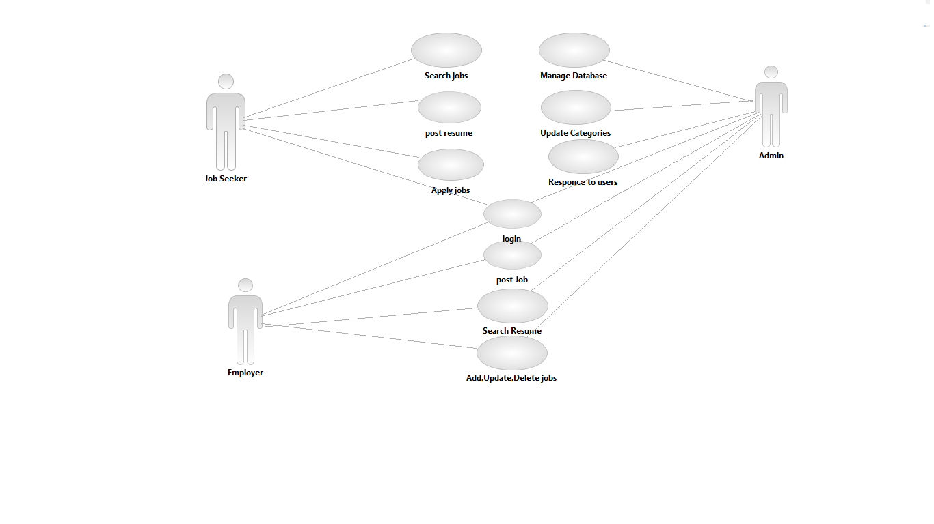

**6.3Sequence Diagram**



**6.4 Activity Diagram**



**6.5 E – R DIAGRAMS:**

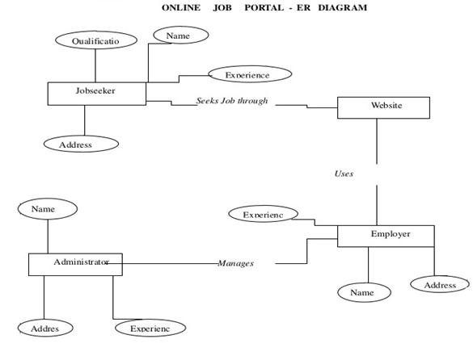

**Chapter-7**

**DATABASE SCHEMA**

1. User Register Table

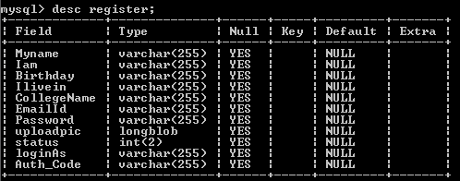

Figure 7.1: Registration table

2. Company Registration Table

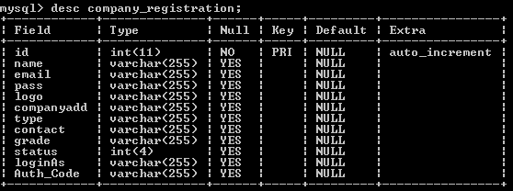

Figure 7.2: Company Registration table

3. Applied Candidates

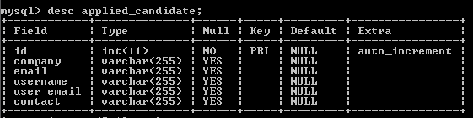

Figure 7.3: Applied Candidates table

4. Job Detail Table

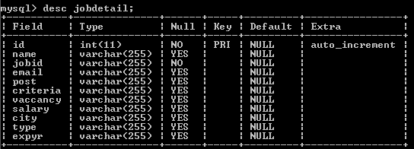

Figure 7.4: Job Details table

5. Resume Table

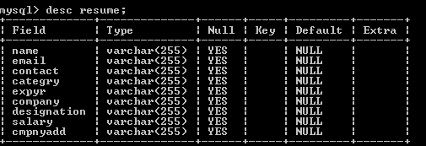

Figure 7.5: Resume table

6. Feedback Table

It holds all the feedbacks given by any user. It contains the full name, contact number and message of the sender.

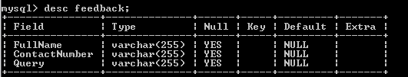

Figure 7.6: Feedback table

7.ContactUs Table

It holds all the queries asked by any user over the internet. It contains the name, email address and the address (optional) of the sender.

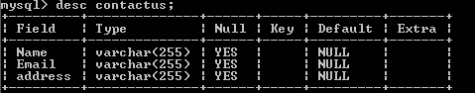

Figure 7.7: ContactUs table

**Chapter 8**

**CONCLUSION:**

* The wider areas of job searching facilitate the quick and easy access to opportunities. The increasing job opportunities and changing scenario of the business environment today has made more people to search for better career and employers to search for better potential.
* This situation has prompted many to move to job portals to look for the ways that has been widely accepted and fully useful in job searching. In this sense the job portals assumes greater importance and we could develop such an efficient system which is used by lot many job hunters and employers.

**FUTURE SCOPE:**

* The future scope of the project is that we can add courses and departments of more than one college and we much other functionality can be added like video conferencing and many others.

**References**

1. www.w3schools.com

2. www.stackoverflow.com

3. www.wikepedia.com

4. www.google.com

5. Internet Programming by Seizer Dater